Sprint 3
Chris Lee, Jaimin Fee, Kurt Schimmel (Team 6)
WhosDown: Mobile app that makes pickup sports easier
1. API Assessment
All WhosDown data (games, RSVPs, profiles, friends, groups, messages, reviews, notifications) is created by our own users. We do not need data from an outside provider for it, and Firebase gives us authentication, a real-time database, file storage, and push messaging without running our own server. For these reasons we use Firebase as our backend and do not build a custom API.
Two outside services supply the data that users do not create:
Need | Service | Why
Accounts, sign-in, guest browsing | Firebase Authentication (email/password + anonymous) | Built-in guest mode; anonymous accounts can be upgraded to email accounts later
App data | Cloud Firestore | Real-time listeners keep rosters, RSVP status, and chat up to date without polling
Profile photos, game photos and clips, group photos | Firebase Storage | Files are stored in Storage; Firestore keeps only the download URL
Push notifications | Firebase Cloud Messaging (FCM) | Approvals, game changes, cancellations, waitlist spots, messages
Map, place search, user location, distance | Apple MapKit + Core Location | Native on iOS, no API key, no cost. Replaces the Google Maps plan from Sprint 1
Weather for outdoor games | Open-Meteo forecast API | Free, no API key. Answers our users' "will the field be playable?" concern (Section 4)
Add game to calendar | EventKit (on device) | Writes the game to the user's calendar

Change since Sprint 1: we replaced the Google Maps SDK and Places API with Apple MapKit (Map, MKLocalSearch). MapKit covers map pins, place search, and distance, needs no key or billing account, and fits SwiftUI directly.
2. Firebase JSON Structure and Setup
2.1 Collection tree
users/{userId} public profile + stats
private/settings owner-only settings (one document)
friends/{friendId} friend list and friend requests
notifications/{notificationId} in-app notification inbox
venues/{venueId} fields, courts, gyms
games/{gameId} pickup games
rsvps/{userId} one per player (pending, approved, waitlisted, ...)
groups/{groupId} play groups / clubs
members/{userId} group membership
conversations/{conversationId} direct, game, and group chats
messages/{messageId} chat messages
reviews/{reviewId} post-game player reviews
reports/{reportId} safety reports

Design notes
- Denormalized fields. Values that many screens show (hostName, venueName, joinedCount, attendeePreview, displayName on RSVPs) are copied into the parent document. A list screen then needs one query, not one query per row.
- RSVP document ID = user ID. A user can have only one RSVP per game, and the app can read games/{gameId}/rsvps/{me} directly.
- Counters (joinedCount, pendingCount, waitlistCount, memberCount) are changed in the same Firestore transaction as the RSVP or member write, so they always match.
- Location search. Firestore has no radius query, so each game and venue stores a geohash. The app queries the geohash ranges that cover the search radius, then filters by exact distance on the device.
- Text search. Firestore has no full-text search, so titleLowercase, nameLowercase, and displayNameLowercase support prefix search on the Search screen (H48).
- Private data. Email, notification preferences, privacy settings, blocked users, and push tokens are in users/{id}/private/settings, which only the owner can read.
In the examples below, Firestore Timestamp values are written as ISO 8601 strings and GeoPoint values as {latitude, longitude}. Every collection has at least one populated record.
2.2 Documents
users/{userId} — public profile
{
"displayName": "Jamie Morales",
"displayNameLowercase": "jamie morales",
"photoURL": null,
"bio": "Midfielder. I organize weeknight games and keep them welcoming but organized.",
"homeArea": "Oakland / CMU",
"schoolLine": "CMU '27",
"position": "Midfielder",
"isVerified": true,
"isGuest": false,
"playStyles": ["social", "competitive"],
"sportLevels": { "soccer": "intermediate", "tennis": "casual" },
"stats": {
"gamesRSVPd": 32,
"gamesAttended": 31,
"gamesHosted": 14,
"mvpCount": 2,
"playAgainYes": 16,
"playAgainTotal": 18,
"feedbackTagCounts": { "reliable": 12, "goodSport": 9, "communicative": 7 },
"recentFeedback": ["Clear communication and always shows up."],
"avgResponseMinutes": 20
},
"createdAt": "2026-09-01T18:22:00Z"
}

users/{userId}/private/settings — readable and writable by the owner only
{
"email": "alex.morgan@example.com",
"notificationPrefs": {
"approvals": true,
"timeOrLocationChanges": true,
"cancellations": true,
"reviewReminders": true,
"newNearbyGames": false,
"groupActivity": false,
"messages": true
},
"newGameAlert": {
"sports": ["soccer", "tennis"],
"radiusMiles": 3.0,
"weekdaysOnly": true,
"earliestHour": 17,
"skillLevels": ["allLevels"]
},
"privacy": {
"gameActivity": "friends",
"profileVisibility": "whosDownPlayers",
"directMessages": "friendsAndTeammates",
"friendRequests": "everyone"
},
"blockedUserIds": ["u_83jd"],
"favoriteVenueIds": ["v_cmu_soccer", "v_schenley_oval"],
"pinnedGroupIds": ["g_westside"],
"searchRadiusMiles": 3.0,
"fcmTokens": ["<device push token>"]
}

users/{userId}/friends/{friendId} — status is requestSent, requestReceived, or friends
{
"displayName": "Mina Kim",
"status": "friends",
"mutualCount": 4,
"since": "2026-10-02T23:10:00Z"
}

users/{userId}/notifications/{notificationId}
{
"type": "gameUpdated",
"title": "Pickup Soccer changed location",
"body": "Jamie: \"Lights are better on the lower turf.\"",
"gameId": "gm_7d2k",
"groupId": null,
"conversationId": null,
"change": {
"field": "location",
"oldValue": "CMU Upper Turf",
"newValue": "CMU Lower Turf",
"hostNote": "Lights are better on the lower turf."
},
"expiresAt": null,
"isRead": false,
"createdAt": "2026-10-28T22:41:00Z"
}

venues/{venueId}
{
"name": "CMU Soccer Field",
"address": "5000 Forbes Ave, Pittsburgh, PA 15213",
"location": { "latitude": 40.4433, "longitude": -79.9436 },
"geohash": "dppnhf",
"isIndoor": false,
"surface": "turf",
"hasLights": true,
"sports": ["soccer", "football", "ultimate"],
"createdBy": "u_jamie"
}

games/{gameId}
{
"title": "Pickup Soccer",
"titleLowercase": "pickup soccer",
"sport": "soccer",
"customSportName": null,
"description": "Friendly all-level pickup.",
"notes": "Bring a light + dark shirt. Need 1 goalkeeper.",
"hostId": "u_jamie",
"hostName": "Jamie Morales",
"groupId": null,
"venueId": "v_cmu_soccer",
"venueName": "CMU Soccer Field",
"location": { "latitude": 40.4433, "longitude": -79.9436 },
"geohash": "dppnhf",
"isIndoor": false,
"surface": "turf",
"hasLights": true,
"startTime": "2026-10-28T23:00:00Z",
"endTime": "2026-10-29T00:30:00Z",
"skillLevel": "allLevels",
"visibility": "public",
"joinType": "approvalRequired",
"priceCents": 0,
"playerLimit": 14,
"waitlistEnabled": true,
"joinedCount": 12,
"pendingCount": 2,
"waitlistCount": 0,
"attendeePreview": ["AM", "MK", "JB", "TP", "CL", "RS"],
"fieldReserved": true,
"reservationWindow": "6:45–8:45 PM",
"facilityNote": "No field conflict.",
"mediaURLs": [],
"status": "scheduled",
"cancelReason": null,
"conversationId": "c_gm_7d2k",
"createdAt": "2026-10-24T15:02:00Z",
"updatedAt": "2026-10-25T21:40:00Z"
}

games/{gameId}/rsvps/{userId} — status is pending, approved, declined, waitlisted, left, or removed
{
"userId": "u_taylor",
"displayName": "Taylor Ross",
"reliability": 0.88,
"skillLevel": "beginner",
"status": "pending",
"isHost": false,
"noteToHost": "Happy to play defense or learn in goal.",
"hostResponse": null,
"waitlistPosition": null,
"spotOfferExpiresAt": null,
"attended": null,
"personalNote": null,
"requestedAt": "2026-10-25T20:15:00Z",
"respondedAt": null
}

groups/{groupId}
{
"name": "West Side Pickup Crew",
"nameLowercase": "west side pickup crew",
"description": "Friendly weeknight soccer. Newcomers welcome.",
"photoURL": null,
"sports": ["soccer"],
"localArea": "Oakland / CMU",
"visibility": "public",
"membershipType": "open",
"ownerId": "u_jamie",
"memberCount": 48,
"conversationId": "c_grp_westside",
"createdAt": "2026-09-10T00:00:00Z"
}

groups/{groupId}/members/{userId} — role is owner, admin, member, or pending
{
"displayName": "Alex Morgan",
"role": "member",
"joinedAt": "2026-10-01T19:00:00Z"
}

conversations/{conversationId} — one collection for direct, game, and group chats
{
"type": "game",
"title": "Pickup Soccer",
"gameId": "gm_7d2k",
"groupId": null,
"participantIds": ["u_jamie", "u_alex", "u_mina"],
"lastMessageText": "Thanks! Field is the lower turf now.",
"lastMessageAt": "2026-10-28T22:24:00Z",
"unreadCounts": { "u_alex": 0, "u_mina": 2 }
}

conversations/{conversationId}/messages/{messageId}
{
"senderId": "u_mina",
"senderName": "Mina Kim",
"text": "Can someone bring an extra ball?",
"mediaURL": null,
"sentAt": "2026-10-28T22:12:00Z"
}

reviews/{reviewId}
{
"gameId": "gm_7d2k",
"reviewerId": "u_alex",
"revieweeId": "u_jamie",
"isMVP": true,
"playAgain": true,
"tags": ["reliable", "goodSport"],
"comment": "Clear communication and made sure everyone was involved.",
"createdAt": "2026-10-29T01:05:00Z"
}

reports/{reportId} — status is open, reviewing, or resolved
{
"reporterId": "u_alex",
"reportedUserId": "u_83jd",
"gameId": "gm_7d2k",
"reason": "noShow",
"details": "RSVP'd to three games and didn't come to any.",
"status": "open",
"createdAt": "2026-10-29T02:00:00Z"
}

Firebase Storage paths (only the download URL is saved in Firestore):
Path | Saved in
users/{userId}/avatar.jpg | users/{userId}.photoURL
games/{gameId}/media/{fileId} | games/{gameId}.mediaURLs[]
groups/{groupId}/photo.jpg | groups/{groupId}.photoURL
conversations/{conversationId}/{fileId} | messages/{messageId}.mediaURL

2.3 Proof that the database is set up
We built a small test app, WhosDownDataCheck, that holds 23 sample documents covering every collection above (4 users, settings, a friend, a notification, 2 venues, 2 games, 3 RSVPs, a group, 2 members, 2 conversations, 2 messages, a review, and a report).
- Models tab: all 23 / 23 documents, including Firestore Timestamp and GeoPoint values, decode into the Swift structs in Section 3 with Firestore.Decoder. This proves the JSON and the structs match.
- Firestore tab: "Seed sample data" writes all 23 documents to our Firebase project in one batch, and "Load from Firestore" reads every collection back with document.data(as:).
Live Firebase project. The sample data is in our Firebase project WhosDown (whosdown-57e99, Cloud Firestore in test mode). The Seed button wrote all 23 documents, and the app read them back.
The screenshots below show the populated database in the Firebase console and our test app decoding and reading it back. Our supervising TA (atorresv@andrew.cmu.edu) also has Viewer access to the Firebase project to check the data directly.
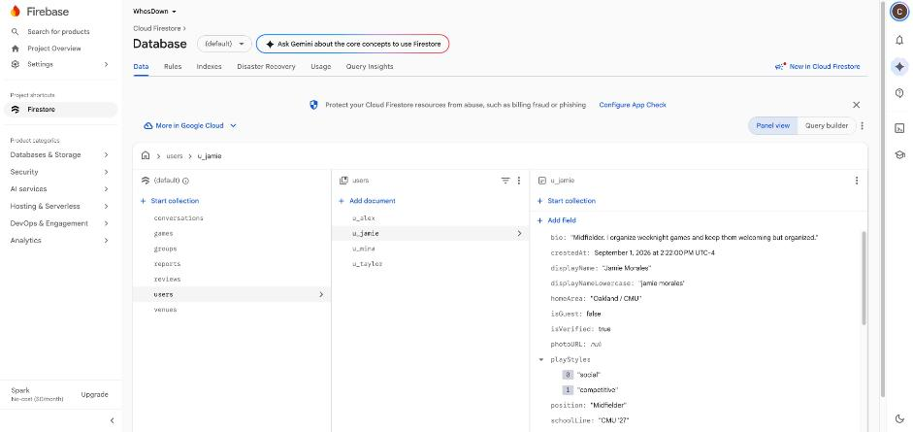
Firebase console: the users collection with a document open
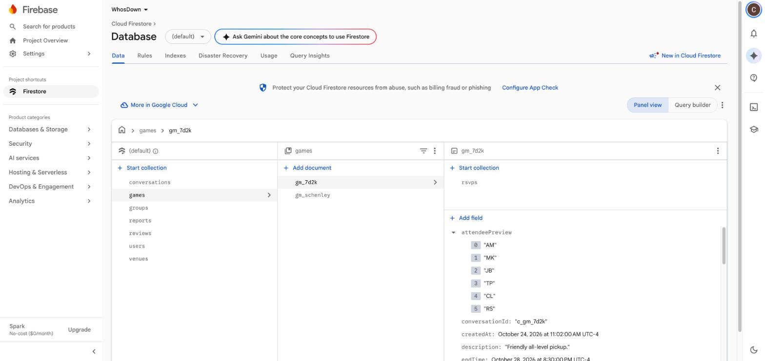
Firebase console: all 7 top-level collections, with game gm_7d2k open
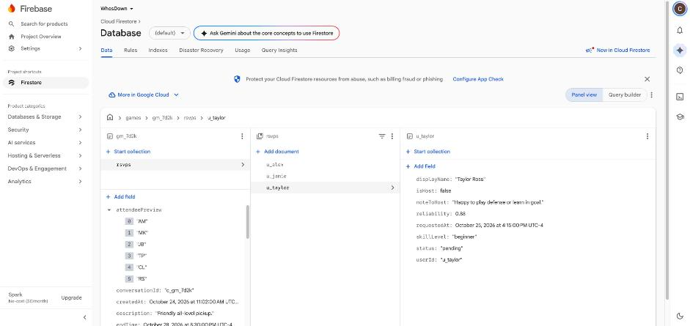
Firebase console: the games/gm_7d2k/rsvps subcollection
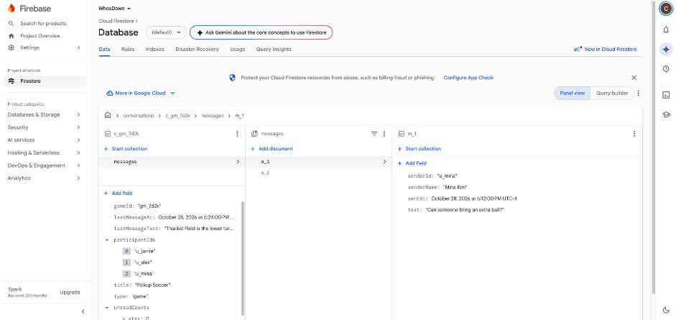
Firebase console: the conversations/c_gm_7d2k/messages subcollection
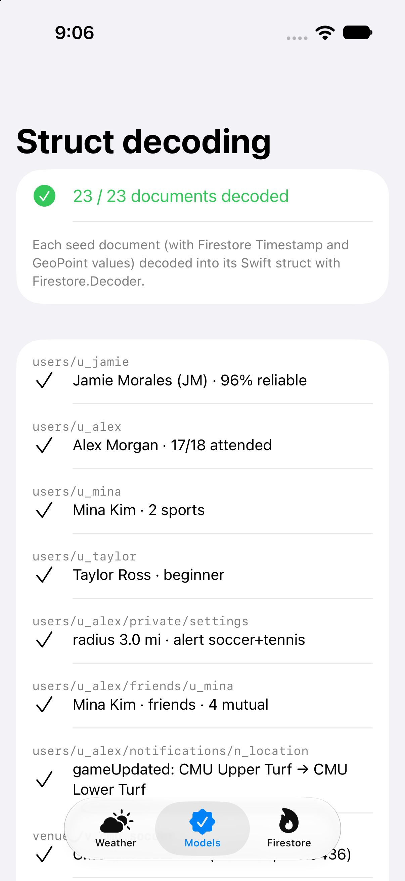
Test app, Models tab: 23 / 23 sample documents decoded into the Swift structs
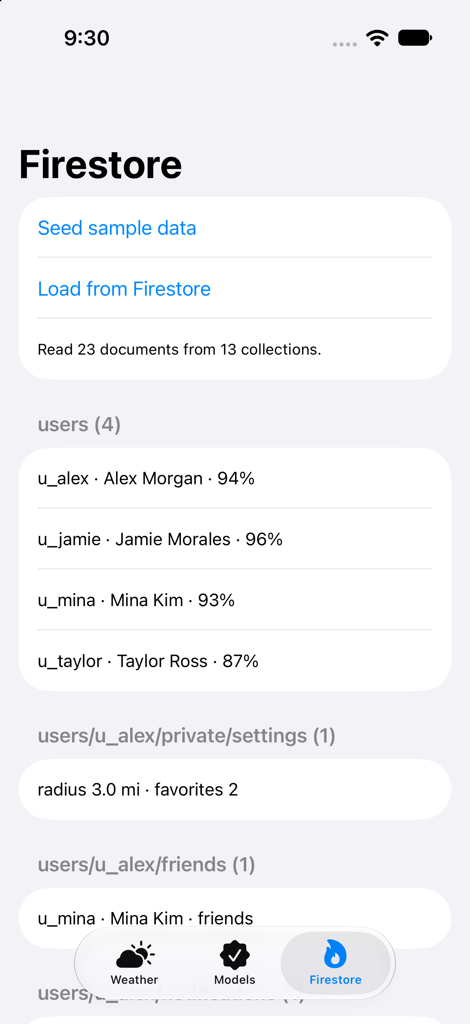
Test app, Firestore tab: 23 documents read back from 13 collections
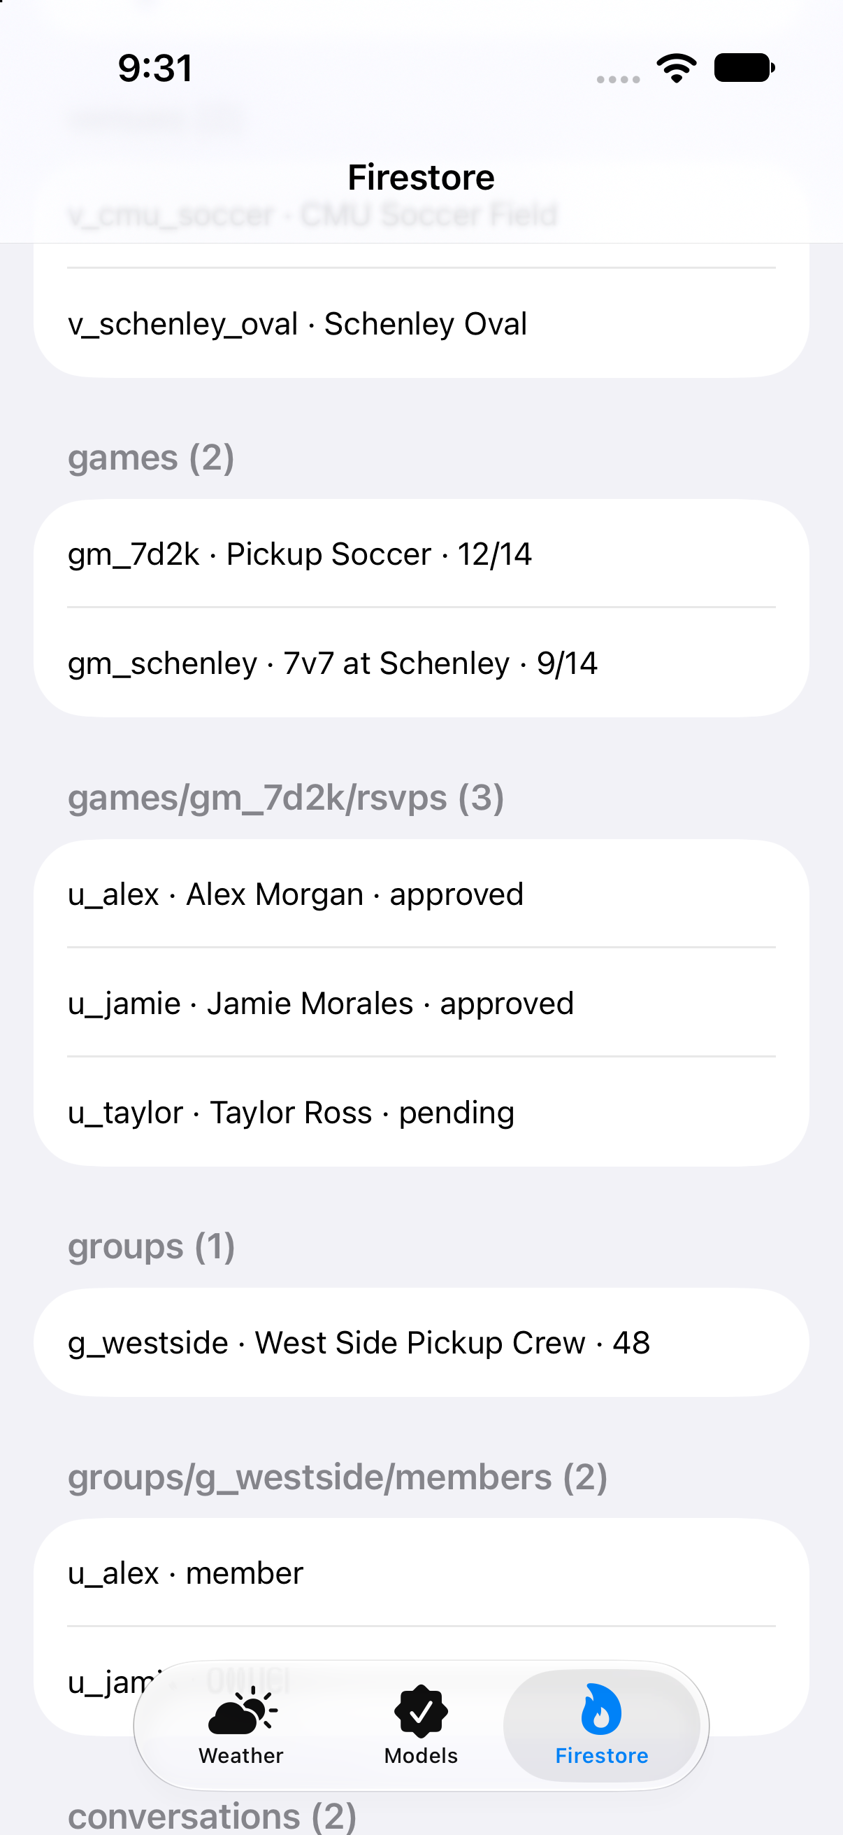
Test app, Firestore tab (scrolled): venues, games, RSVPs, groups, and members read back
3. Swift Structs
Each struct matches one Firestore document type and decodes directly with document.data(as:). Computed properties (initials, reliability, isFree, isFull, spotsLeft, sportName) give the screens values they need without storing them twice. The Open-Meteo structs are in Section 4.
import Foundation
import FirebaseFirestore

// WhosDown app models. Each struct matches one Firestore document type
// and decodes directly with `document.data(as:)`.

// MARK: - Shared enums

enum Sport: String, Codable, CaseIterable {
case soccer, basketball, tennis, volleyball, pickleball, baseball, football, ultimate, other
}

enum SkillLevel: String, Codable, CaseIterable {
case beginner, casual, allLevels, intermediate, competitive
}

enum PlayStyle: String, Codable, CaseIterable {
case social, competitive, learning
}

enum Visibility: String, Codable {
case `public`, `private`
}

enum JoinType: String, Codable {
case open, approvalRequired
}

enum GameStatus: String, Codable {
case scheduled, cancelled, completed
}

enum RSVPStatus: String, Codable {
case pending, approved, declined, waitlisted, left, removed
}

enum AudienceSetting: String, Codable {
case everyone, whosDownPlayers, friendsAndTeammates, friends, nobody
}

enum FeedbackTag: String, Codable, CaseIterable {
case reliable, goodSport, communicative, welcoming, competitive, helpful
}

// MARK: - users/{userId}

struct AppUser: Codable, Identifiable {
@DocumentID var id: String?
var displayName: String
var displayNameLowercase: String
var photoURL: String?
var bio: String
var homeArea: String
var schoolLine: String?
var position: String?
var isVerified: Bool
var isGuest: Bool
var playStyles: [PlayStyle]
var sportLevels: [String: SkillLevel]
var stats: PlayerStats
var createdAt: Date

var initials: String {
displayName.split(separator: " ").prefix(2).compactMap(\.first).map(String.init).joined()
}
}

struct PlayerStats: Codable {
var gamesRSVPd: Int
var gamesAttended: Int
var gamesHosted: Int
var mvpCount: Int
var playAgainYes: Int
var playAgainTotal: Int
var feedbackTagCounts: [String: Int]
var recentFeedback: [String]
var avgResponseMinutes: Int?

var reliability: Double? {
gamesRSVPd == 0 ? nil : Double(gamesAttended) / Double(gamesRSVPd)
}
}

// MARK: - users/{userId}/private/settings

struct UserSettings: Codable {
var email: String
var notificationPrefs: NotificationPrefs
var newGameAlert: NewGameAlertRule?
var privacy: PrivacySettings
var blockedUserIds: [String]
var favoriteVenueIds: [String]
var pinnedGroupIds: [String]
var searchRadiusMiles: Double
var fcmTokens: [String]
}

struct NotificationPrefs: Codable {
var approvals: Bool
var timeOrLocationChanges: Bool
var cancellations: Bool
var reviewReminders: Bool
var newNearbyGames: Bool
var groupActivity: Bool
var messages: Bool
}

struct NewGameAlertRule: Codable {
var sports: [Sport]
var radiusMiles: Double
var weekdaysOnly: Bool
var earliestHour: Int
var skillLevels: [SkillLevel]
}

struct PrivacySettings: Codable {
var gameActivity: AudienceSetting
var profileVisibility: AudienceSetting
var directMessages: AudienceSetting
var friendRequests: AudienceSetting
}

// MARK: - users/{userId}/friends/{friendId}

enum FriendStatus: String, Codable {
case requestSent, requestReceived, friends
}

struct Friendship: Codable, Identifiable {
@DocumentID var id: String?
var displayName: String
var status: FriendStatus
var mutualCount: Int
var since: Date
}

// MARK: - users/{userId}/notifications/{notificationId}

enum NotificationType: String, Codable {
case approved, declined, gameUpdated, gameCancelled, spotOpen, message, groupActivity, reviewReminder, newGame
}

struct AppNotification: Codable, Identifiable {
@DocumentID var id: String?
var type: NotificationType
var title: String
var body: String
var gameId: String?
var groupId: String?
var conversationId: String?
var change: GameChange?
var expiresAt: Date?
var isRead: Bool
var createdAt: Date
}

struct GameChange: Codable {
var field: String
var oldValue: String
var newValue: String
var hostNote: String?
}

// MARK: - venues/{venueId}

struct Venue: Codable, Identifiable {
@DocumentID var id: String?
var name: String
var address: String
var location: GeoPoint
var geohash: String
var isIndoor: Bool
var surface: String?
var hasLights: Bool
var sports: [Sport]
var createdBy: String
}

// MARK: - games/{gameId}

struct Game: Codable, Identifiable {
@DocumentID var id: String?
var title: String
var titleLowercase: String
var sport: Sport
var customSportName: String?
var description: String
var notes: String?
var hostId: String
var hostName: String
var groupId: String?

var venueId: String
var venueName: String
var location: GeoPoint
var geohash: String
var isIndoor: Bool
var surface: String?
var hasLights: Bool

var startTime: Date
var endTime: Date

var skillLevel: SkillLevel
var visibility: Visibility
var joinType: JoinType
var priceCents: Int
var playerLimit: Int
var waitlistEnabled: Bool

var joinedCount: Int
var pendingCount: Int
var waitlistCount: Int
var attendeePreview: [String]

var fieldReserved: Bool
var reservationWindow: String?
var facilityNote: String?
var mediaURLs: [String]

var status: GameStatus
var cancelReason: String?
var conversationId: String
var createdAt: Date
var updatedAt: Date

var isFree: Bool { priceCents == 0 }
var isFull: Bool { joinedCount >= playerLimit }
var spotsLeft: Int { max(playerLimit - joinedCount, 0) }
var sportName: String { customSportName ?? sport.rawValue.capitalized }
}

// MARK: - games/{gameId}/rsvps/{userId}

struct RSVP: Codable, Identifiable {
@DocumentID var id: String?
var userId: String
var displayName: String
var reliability: Double?
var skillLevel: SkillLevel?
var status: RSVPStatus
var isHost: Bool
var noteToHost: String?
var hostResponse: String?
var waitlistPosition: Int?
var spotOfferExpiresAt: Date?
var attended: Bool?
var personalNote: String?
var requestedAt: Date
var respondedAt: Date?
}

// MARK: - groups/{groupId}

enum MembershipType: String, Codable {
case open, requestToJoin
}

struct PlayGroup: Codable, Identifiable {
@DocumentID var id: String?
var name: String
var nameLowercase: String
var description: String
var photoURL: String?
var sports: [Sport]
var localArea: String
var visibility: Visibility
var membershipType: MembershipType
var ownerId: String
var memberCount: Int
var conversationId: String
var createdAt: Date
}

// MARK: - groups/{groupId}/members/{userId}

enum GroupRole: String, Codable {
case owner, admin, member, pending
}

struct GroupMember: Codable, Identifiable {
@DocumentID var id: String?
var displayName: String
var role: GroupRole
var joinedAt: Date
}

// MARK: - conversations/{conversationId}

enum ConversationType: String, Codable {
case direct, game, group
}

struct Conversation: Codable, Identifiable {
@DocumentID var id: String?
var type: ConversationType
var title: String
var gameId: String?
var groupId: String?
var participantIds: [String]
var lastMessageText: String?
var lastMessageAt: Date?
var unreadCounts: [String: Int]
}

// MARK: - conversations/{conversationId}/messages/{messageId}

struct Message: Codable, Identifiable {
@DocumentID var id: String?
var senderId: String
var senderName: String
var text: String
var mediaURL: String?
var sentAt: Date
}

// MARK: - reviews/{reviewId}

struct Review: Codable, Identifiable {
@DocumentID var id: String?
var gameId: String
var reviewerId: String
var revieweeId: String
var isMVP: Bool
var playAgain: Bool
var tags: [FeedbackTag]
var comment: String?
var createdAt: Date
}

// MARK: - reports/{reportId}

enum ReportReason: String, Codable {
case harassment, noShow, misleadingEvent, other
}

enum ReportStatus: String, Codable {
case open, reviewing, resolved
}

struct Report: Codable, Identifiable {
@DocumentID var id: String?
var reporterId: String
var reportedUserId: String
var gameId: String?
var reason: ReportReason
var details: String?
var status: ReportStatus
var createdAt: Date
}

4. External API: Open-Meteo Weather
4.1 Why we use it
In our Sprint 1 interviews, field conditions and uncertainty were the top pain point ("playing pickup is a bet on that day's session"). For outdoor games, the app shows a weather line such as "64°F · Clear · 8% rain · Outdoor" on Game Detail (H09), Joined Game (H14), Venue & Details (H18), and Review & Publish (H19). The line is hidden when Game.isIndoor == true.
Open-Meteo is free for non-commercial use and needs no API key, so the playground runs as-is.
4.2 Request
GET https://api.open-meteo.com/v1/forecast
?latitude=40.4433
&longitude=-79.9436
&hourly=temperature_2m,precipitation_probability,weather_code,wind_speed_10m
&temperature_unit=fahrenheit
&wind_speed_unit=mph
&timezone=America/New_York
&forecast_days=7

latitude and longitude come from Game.location (a Firestore GeoPoint). Seven days covers any game a user can see on Discover.
4.3 Response (shortened — the real response has 168 hourly rows)
{
"latitude": 40.4349,
"longitude": -79.93617,
"utc_offset_seconds": -14400,
"timezone": "America/New_York",
"hourly_units": {
"time": "iso8601",
"temperature_2m": "°F",
"precipitation_probability": "%",
"weather_code": "wmo code",
"wind_speed_10m": "mp/h"
},
"hourly": {
"time": ["2026-10-25T00:00", "2026-10-25T01:00"],
"temperature_2m": [46.9, 44.9],
"precipitation_probability": [0, 0],
"weather_code": [0, 0],
"wind_speed_10m": [4.8, 2.9]
}
}

The response uses parallel arrays: index i of every array is the same hour. The app turns them into one HourlyForecast per hour, then picks the hour closest to Game.startTime.
4.4 Structs (same code as the playground)
// MARK: - Decodable structs for the Open-Meteo response

struct ForecastResponse: Decodable {
let latitude: Double
let longitude: Double
let timezone: String
let utcOffsetSeconds: Int
let hourlyUnits: HourlyUnits
let hourly: Hourly

enum CodingKeys: String, CodingKey {
case latitude, longitude, timezone
case utcOffsetSeconds = "utc_offset_seconds"
case hourlyUnits = "hourly_units"
case hourly
}
}

struct HourlyUnits: Decodable {
let temperature: String
let windSpeed: String

enum CodingKeys: String, CodingKey {
case temperature = "temperature_2m"
case windSpeed = "wind_speed_10m"
}
}

// Open-Meteo returns parallel arrays: index i of every array is the same hour.
struct Hourly: Decodable {
let time: [String]
let temperature: [Double]
let precipitationProbability: [Int]
let weatherCode: [Int]
let windSpeed: [Double]

enum CodingKeys: String, CodingKey {
case time
case temperature = "temperature_2m"
case precipitationProbability = "precipitation_probability"
case weatherCode = "weather_code"
case windSpeed = "wind_speed_10m"
}
}

// MARK: - App-side struct the interface reads

struct HourlyForecast {
let date: Date
let temperatureF: Double
let precipitationProbability: Int
let weatherCode: Int
let windSpeedMph: Double

// WMO weather codes used by Open-Meteo
var conditionText: String {
switch weatherCode {
case 0: return "Clear"
case 1: return "Mostly clear"
case 2: return "Partly cloudy"
case 3: return "Overcast"
case 45, 48: return "Fog"
case 51, 53, 55, 56, 57: return "Drizzle"
case 61, 63, 65, 66, 67: return "Rain"
case 71, 73, 75, 77: return "Snow"
case 80, 81, 82: return "Rain showers"
case 85, 86: return "Snow showers"
case 95, 96, 99: return "Thunderstorm"
default: return "Unknown"
}
}

// Line shown on H09 / H14 / H18, e.g. "64°F · Clear · 8% rain"
var summaryLine: String {
"\(Int(temperatureF.rounded()))°F · \(conditionText) · \(precipitationProbability)% rain"
}
}

extension ForecastResponse {
// Turns the parallel arrays into one HourlyForecast per hour.
// Times come back in local time without an offset, so the response's
// utc_offset_seconds is applied when parsing.
var hours: [HourlyForecast] {
let formatter = DateFormatter()
formatter.locale = Locale(identifier: "en_US_POSIX")
formatter.dateFormat = "yyyy-MM-dd'T'HH:mm"
formatter.timeZone = TimeZone(secondsFromGMT: utcOffsetSeconds)

return hourly.time.indices.compactMap { i in
guard let date = formatter.date(from: hourly.time[i]) else { return nil }
return HourlyForecast(
date: date,
temperatureF: hourly.temperature[i],
precipitationProbability: hourly.precipitationProbability[i],
weatherCode: hourly.weatherCode[i],
windSpeedMph: hourly.windSpeed[i]
)
}
}

// The hour closest to a game's start time.
func forecast(closestTo date: Date) -> HourlyForecast? {
hours.min { abs($0.date.timeIntervalSince(date)) < abs($1.date.timeIntervalSince(date)) }
}
}

4.5 Playground (WhosDownWeather.playground, submitted with this document)
The playground uses URLSession with async/await to request the forecast for two sample games (the same venues as our Firestore sample data), decodes the response with JSONDecoder into ForecastResponse, and prints the hour closest to each game's start time. Open it in Xcode and press Run. It also runs from Terminal with swift Contents.swift.
Output (run on Oct 25, 2026):
WhosDown weather check — Open-Meteo
==================================
Pickup Soccer @ CMU Soccer Field
Start: Mon Oct 26, 7:00 PM
Decoded 168 hourly rows for (40.4349, -79.93617), America/New_York
Hour: Mon Oct 26, 7:00 PM
60°F · Overcast · 1% rain · Outdoor
Wind 1 mph
7v7 at Schenley @ Schenley Oval
Start: Mon Oct 26, 8:15 PM
Decoded 168 hourly rows for (40.4349, -79.93617), America/New_York
Hour: Mon Oct 26, 8:00 PM
57°F · Overcast · 1% rain · Outdoor
Wind 3 mph
Done.

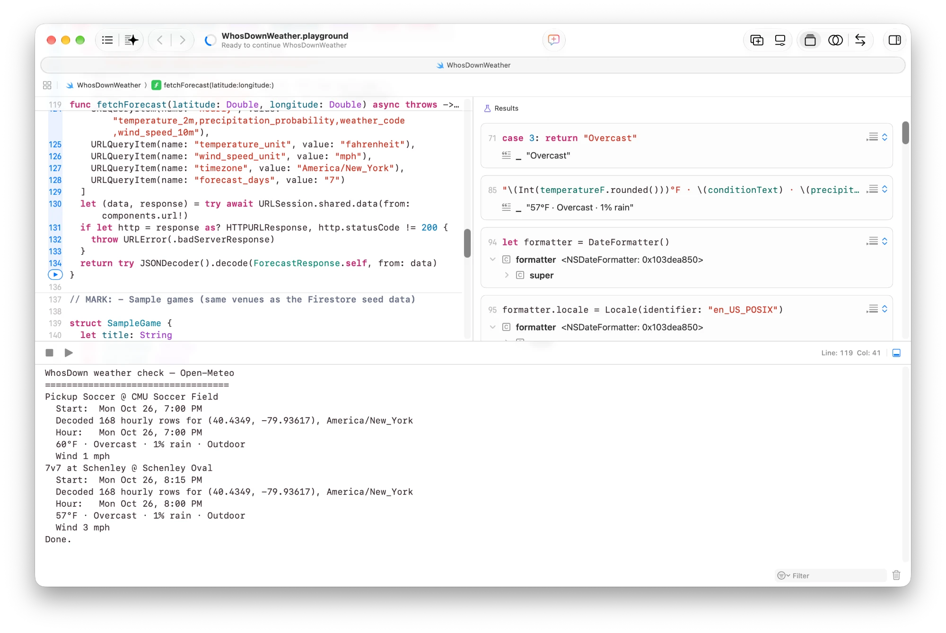
The playground run in Xcode, console output at the bottom
The same code also runs inside our test app (below), where each sample Game decoded from Firestore data is passed to fetchForecast with its GeoPoint.
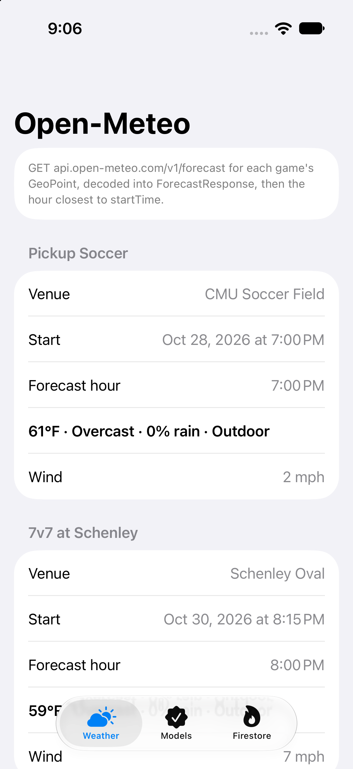
Open-Meteo data decoded in the test app
4.6 Apple MapKit and Core Location
MapKit is an on-device framework, not a JSON API, so it needs no playground. It supplies:
Data | API | Screens
Map, pins, radius circle | SwiftUI Map, Annotation, MapCircle | H06, H40
Place / address search | MKLocalSearch → MKMapItem (name, address, coordinate) saved as a new Venue | H40
User location | CLLocationManager (when-in-use) | H05, H06, H07
Distance to a game or venue | CLLocation.distance(from:), shown in miles | H06, H07, H09, H23, H40, H53, H56

5. Internal API and On-Device Store
- Internal API: not applicable. We use Firebase instead of a custom server (Section 1). All reads and writes go through the Firebase iOS SDK, and every data source is listed in Section 8.2.
- SwiftData: not applicable. WhosDown does not keep its own on-device database. Firestore's built-in offline cache keeps recently loaded games, RSVPs, and messages available without a connection and syncs writes when the device reconnects. Small view preferences (for example, the last-used Discover filters) use @AppStorage.
6. Interactive Prototype
Figma prototype: https://www.figma.com/proto/4dTTJVikeBUzFTG9KnSowN/Who-sDown-%E2%80%94-Lo-fi-Wireframes?node-id=104-23&m=dev&scaling=min-zoom&content-scaling=fixed&page-id=104%3A16&starting-point-node-id=104%3A23
The prototype is built from our 63 high-fidelity screens (H01–H63, Figma page "03 — Hi-Fi Full Marks"). It looks like the real app and clicks through to the right screens, but it does not save data. The tab bar (Discover, My Games, Create, Social, Profile) works from every main screen.
Flows the prototype covers
Flow | Screens
Sign up and onboarding | H01 Welcome → H02 Create Account → H03 Select Sports → H42 Skill Levels → H04 Complete Profile → H05 Permissions → H43 Notification Permission → H44 Onboarding Complete
Sign in / guest | H01 → H41 Sign In; H01 → "Explore as guest" → H06; guest taps Join → H34 Guest Join Gate
Find a game | H06 Discover Map ↔ H07 Discover List → H08 Filters → H09 Game Detail → H10 Organizer Profile, H11 Player Roster; H48 Search
Join a game (approval) | H09 → H12 Join Review → H13 Pending → H14 Joined Game (approved) or H35 Declined
Full game / waitlist | H09 → H15 Full / Waitlist → H53 Waitlist Spot Available → claim spot
Coordinate | H14 → H16 Event Chat; H14 → H37 Leave Confirmation
Host a game | H17 Create Activity → H40 Choose Location → H18 Venue & Details → H19 Review & Publish → H45 Game Created
Manage a game | H20 Host Dashboard → H21 Join Requests, H46 Edit Game, H22 Transfer Host, H38 Cancel Game
Social | H23 Friends Activity, H24 Direct Messages → H39 Message Thread; H25 Groups Discover → H26 Group Detail; H47 Create Group
History and reputation | H27 My Games → H28 Past Games → H29 Past Game Summary → H30 Post-game Review; H60 Review Players → H61 Player Review Detail → H62 Review Summary (H63 changed state)
Notifications | H31 Notifications → H50 All Notifications → H51 Game Update, H52 Game Cancelled, H53 Spot Available, H54 Message, H55 Group Activity
Profile and settings | H36 Profile & Preferences → H49 Edit Profile, H32 Notification Settings, H56 Favorite Fields, H57 Privacy Settings, H58 Reliability & Reviews, H59 Account & Security; H33 Safety & Reporting

7. User Testing Report
The full report is a separate document, WhosDown (Team 6) Sprint 3 - User Interviews Report. It covers the method, the 4 participants, what worked, 23 lessons learned with the change each one causes, and the full interview notes. In short:
- Testers trust the app more when they know who the host is, what the game costs, and who else is going. Safety came up strongly (P4), so reporting moves into V1 and host reputation stays a top V2 item.
- Testers expect the app to remind them. A local reminder before each approved game is added to V1, because it needs no server. Push alerts stay in V2.
- The biggest requests are social and group features: friends attending, mutual friends, group profiles with schedules, sharing, and favorites. They confirm our V2 plan and add six V2 items (2.18–2.23).
- Watching testers use the screens showed clarity problems in the core loop: the organizer profile was hard to find, testers did not understand approval, leaving, or what happens when a game fills up or ends, and statuses all looked alike. These fixes go into V1 (lessons 16–20, 22), together with a layout pass (1.26).
- Testers liked the clean interface, the map, how easy it was to post a game, private games, and the roster. No tester asked to remove a feature, and the core loop (find, join, host) stays the same.
8. Wireframe Data Mapping
This section maps every piece of data on the 63 high-fidelity screens to where it comes from (8.2) and which field or Swift property holds it (8.3). Static text (headings, helper text, button labels) is not marked.
Marked-up wireframes (Figma): page "05 — Sprint 3 Data Mapping" in our Figma file (https://www.figma.com/design/4dTTJVikeBUzFTG9KnSowN). It holds a copy of each of the 63 hi-fi screens. Every piece of data on a screen has a numbered, color-coded badge (Firestore, Auth, Storage, Open-Meteo, MapKit, user input, computed). The panel beside each screen lists each badge's source and field, the endpoint IDs from 8.2 that the screen uses, and its release (V1 or V2 from Section 9). An endpoint legend sits to the right of the first row. All 63 marked-up screens are in the separate Mapped Wireframes PDF (8.3).
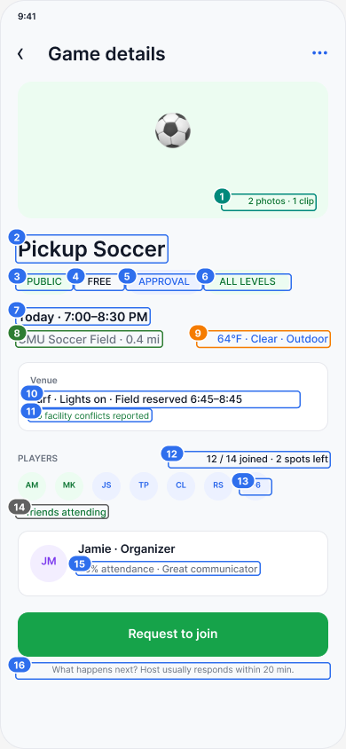
Figma example: H09 Game Detail with numbered data badges
The panel beside H09 in Figma lists each numbered badge:
# | Source | Field
1 | Storage | games.mediaURLs (Storage games/{id}/media)
2 | Firestore | games/{id}.title
3 | Firestore | games.visibility
4 | Firestore | games.priceCents (Game.isFree)
5 | Firestore | games.joinType
6 | Firestore | games.skillLevel
7 | Firestore | games.startTime / endTime
8 | MapKit | games.venueName + distance to games.location
9 | Open-Meteo | Hour closest to startTime (HourlyForecast) + games.isIndoor
10 | Firestore | games.surface, hasLights, fieldReserved, reservationWindow
11 | Firestore | games.facilityNote
12 | Firestore | games.joinedCount, playerLimit, spotsLeft
13 | Firestore | games.attendeePreview
14 | Computed | games/{id}/rsvps (approved) ∩ users/{me}/friends
15 | Firestore | users/{hostId}.stats (PlayerStats.reliability, feedbackTagCounts)
16 | Firestore | users/{hostId}.stats.avgResponseMinutes

Endpoints: R2, R3, R4, R7, R9 · Other sources: Storage, Open-Meteo, MapKit · Release: V1
8.1 Source key
Tag | Meaning
FS | Cloud Firestore document or query (path shown)
Auth | Firebase Authentication (Auth.auth().currentUser)
Storage | Firebase Storage (photos and clips; download URL saved in Firestore)
FCM | Firebase Cloud Messaging push
OM | Open-Meteo forecast API (Section 4)
MK | Apple MapKit / Core Location (map, place search, user location, distance)
Input | Entered by the user on this screen, then written to the FS path shown
Computed | Derived on the device from the fields listed
Local | View state only, not stored

8.2 Data sources ("endpoints")
Because we use Firebase, our "endpoints" are the Firestore queries and writes the app makes. Every screen in the marked-up wireframes (8.3) uses one or more of these.
Firestore reads
ID | Name | Path and query | Type | Screens
R1 | Nearby games | games where geohash in ranges covering the radius, status == "scheduled", visibility == "public", startTime >= now; then exact distance (MK) and filters on device | get | H06, H07, H08, H15, H35, H52
R2 | One game | games/{gameId} | listener | H09, H11–H15, H19–H22, H29, H34, H37, H38, H45, H46, H51–H53, H55
R3 | Game roster | games/{gameId}/rsvps where status == "approved" (or "pending" for the host) | listener | H09, H11, H21, H22, H29, H30, H60
R4 | My RSVP | games/{gameId}/rsvps/{me} | listener | H09, H12–H15, H29, H35, H37, H53
R5 | My RSVPs | collection group rsvps where userId == me; parent games fetched by ID | get | H06 "Next up", H27, H28
R6 | Games I host | games where hostId == me, status == "scheduled" | listener | H20, H27
R7 | User profile | users/{userId} | get | H09 organizer, H10, H11, H29, H36, H39, H49, H58
R8 | My settings | users/{me}/private/settings | listener | H05, H08, H32, H33, H36, H56, H57, H59
R9 | Friends | users/{me}/friends where status == "friends" | listener | H09, H11, H23, H24, H25, H29
R10 | Notifications | users/{me}/notifications order by createdAt desc | listener | H31, H50–H55
R11 | Venues | venues where geohash in ranges, plus favorites by ID | get | H18, H40, H56
R12 | My conversations | conversations where participantIds array-contains me, order by lastMessageAt desc | listener | H20, H24
R13 | Messages | conversations/{id}/messages order by sentAt | listener | H16, H39, H54
R14 | Groups | groups where visibility == "public", sports array-contains-any my sports; groups/{groupId} | get | H25, H26, H55
R15 | Group members | groups/{groupId}/members | get | H25, H26
R16 | Group games | games where groupId == id, startTime >= now (count query for "games this week") | get | H25, H26, H48
R17 | Friends activity | collection group rsvps where userId in friendIds, status == "approved"; collection group members where friend ID, recent joinedAt | get | H23
R18 | My reviews | reviews where reviewerId == me | get | H28
R19 | Search | prefix queries on games.titleLowercase, groups.nameLowercase, users.displayNameLowercase | get | H48

Firestore writes
ID | Action | What is written | Screens
W1 | Create account | users/{uid} + users/{uid}/private/settings | H02–H05, H42–H44
W2 | Edit profile | update users/{me}; photo to Storage | H04, H49
W3 | Publish game | batch: new games/{id} + rsvps/{me} (host, approved) + conversations/{id} (type game) | H19
W4 | Edit game | update games/{id} + gameUpdated notification to each approved player | H46
W5 | Cancel game | games/{id}.status = cancelled, cancelReason + gameCancelled notification to every RSVP | H38
W6 | Join / request / waitlist | transaction: rsvps/{me} + joinedCount, pendingCount, or waitlistCount | H12, H15
W7 | Approve / decline | transaction: rsvps/{userId}.status, respondedAt, hostResponse + counters + notification | H21
W8 | Leave / cancel request | transaction: rsvps/{me}.status = left + counters; first waitlisted RSVP gets spotOfferExpiresAt + spotOpen notification | H13, H37
W9 | Claim spot | transaction: rsvps/{me}.status = approved, joinedCount + 1, waitlistCount − 1 | H53
W10 | Transfer host | games/{id}.hostId, hostName; swap isHost on two RSVPs | H22
W11 | Send message | new messages/{id} + lastMessageText, lastMessageAt, unreadCounts on the conversation | H16, H39
W12 | Friend request / accept | users/{me}/friends/{id} and users/{id}/friends/{me} | H10, H23, H29
W13 | Create / join group | new groups/{id} + members/{me} + conversations (type group); or members/{me} + memberCount + 1 | H26, H47
W14 | Submit reviews | one reviews/{id} per teammate + reviewee stats incremented | H30, H60–H62
W15 | Report / block | new reports/{id}; or blockedUserIds in settings | H33, H57
W16 | Save settings | update users/{me}/private/settings | H05, H08, H26, H32, H43, H56, H57
W17 | Mark read | notifications/{id}.isRead = true; unreadCounts[me] = 0 | H16, H24, H31, H50–H55
W18 | Add venue | new venues/{id} from an MKMapItem | H40
W19 | Personal note | rsvps/{me}.personalNote | H29

Other sources
Source | Calls | Screens
Auth | createUser, signIn, signInAnonymously, link(with:), sendPasswordReset, updatePassword, delete, providerData | H01, H02, H34, H41, H59
Storage | upload / download URL for avatar, game media, group photo, chat photo | H04, H09, H16, H18, H47, H49
FCM | device token saved to fcmTokens; push sent for approvals, changes, cancellations, spot open, messages | H43, H50–H55
OM | GET /v1/forecast (Section 4) | H09, H14, H18, H19
MK | Map, MKLocalSearch, CLLocationManager, distance(from:) | H05, H06, H07, H09, H23, H40, H53, H56
EventKit | add game to calendar | H14

8.3 Screen-by-screen mapping (marked-up wireframes)
The full screen-by-screen mapping is the set of marked-up wireframes itself:
- PDF (submitted with this document): WhosDown (Team 6) Sprint 3 - Mapped Wireframes.pdf. It shows all 63 screens, two per page, each next to its source panel. The color key is in 8.1 and the endpoint IDs are in 8.2.
- Live Figma file: page "05 — Sprint 3 Data Mapping" at https://www.figma.com/design/4dTTJVikeBUzFTG9KnSowN
For every screen, each numbered badge names its source (Firestore path, Auth, Storage, Open-Meteo, MapKit, user input, or computed) and the field or struct property it uses, and the panel lists the endpoints from 8.2 and the release (V1 or V2). H09 above shows the format.
9. Feature List and Delivery Schedule
9.1 Scope rules
- Version 1 is the end of Sprint 4. It delivers the core loop from Sprint 1: find a nearby game → join it → show up, and post a game → manage who comes. A Version 1 feature must work end to end with real Firestore data.
- Version 2 is the final release. It adds the social, reputation, and push features that make users come back.
- Firestore counters and in-app notifications are written by the client in transactions in Version 1. Push notifications need a server to send them, so FCM sending (through Cloud Functions) is in Version 2.
- Dates are the start of each work week. Sprint end dates follow Canvas.
- User testing (Section 7) changed the plan: V1 gained game reminders (1.24), reporting (1.25), and a layout pass (1.26); V1 1.4, 1.7, 1.8, 1.11, 1.14, 1.16, 1.17, 1.19, and 1.22 gained clarity fixes testers asked for; and V2 gained 2.18–2.23.
9.2 Version 1 (end of Sprint 4)
# | Feature | What works in V1 | Screens | Week of
1.1 | Project setup | Xcode project, Firebase SDK, Models.swift, sample data in Firestore, Firestore security rules (owner-only private/settings) | — | Oct 26
1.2 | Account and sign-in | Email sign-up, sign-in, sign-out, password reset | H01, H02, H41 | Oct 26
1.3 | Guest browsing | Anonymous sign-in; guest can browse; Join opens the guest gate, which upgrades the account | H01, H34 | Oct 26
1.4 | Onboarding | Select from all nine sports plus "Other" with a custom name, skill level per sport, basic profile (name, bio, home area, play style), location permission, notification preferences saved | H03, H42, H04, H05, H44 | Oct 26
1.5 | Discover map | MapKit map with user location, radius circle, sport pins from the nearby-games query, pin card, "Next up" card | H06 | Nov 2
1.6 | Discover list | List of nearby games with distance, level, count, price | H07 | Nov 2
1.7 | Filters | Sport, time (Now / Tonight / Tomorrow / custom range), distance typed in miles, skill, join type; distance saved to settings | H08 | Nov 2
1.8 | Game detail | All game facts, distance, venue facts, attendee preview; whole organizer row opens the organizer profile; note that the game moves to Past Games after it ends | H09 | Nov 2
1.9 | Weather | Open-Meteo weather line for outdoor games | H09, H14, H18, H19 | Nov 2
1.10 | Player roster | Approved players with level and reliability | H11 | Nov 2
1.11 | Create game | Sport (including a custom "Other" sport), date/time, skill, player limit, join type, visibility, price (display only), notes, facility details | H17, H18, H19, H45 | Nov 9
1.12 | Choose location | MapKit place search + saved venues; new place saved as a venue | H40 | Nov 9
1.13 | Join an open game | One-tap join; counters update live | H09, H14 | Nov 9
1.14 | Request to join | Join review explains the three approval steps; note to host; Pending; live change to Approved or Declined (with host message); one color per status | H12, H13, H14, H35 | Nov 9
1.15 | Host: approve / decline | Host dashboard and join-request list | H20, H21 | Nov 9
1.16 | Leave game / cancel request | "Leave game" or "Cancel request" button on Game Detail whenever the player has an RSVP; confirmation sheet; counters update | H09, H13, H37 | Nov 9
1.17 | Waitlist | Full games say "Full · Join waitlist" with the waitlist count; join waitlist; first in line gets a 10-minute spot offer when someone leaves; claim spot | H15, H53 | Nov 16
1.18 | Edit and cancel game | Host edits time, location, limit, join type; cancels with a reason; joined players get an in-app notification | H46, H38, H51, H52 | Nov 16
1.19 | My Games | Upcoming (with color-coded status badge), Hosting, and Past lists; games move to Past automatically after they end | H27, H28 | Nov 16
1.20 | Game chat | One chat per game, created on publish; live messages for approved players | H16 | Nov 16
1.21 | In-app notifications | Notification list and detail screens for approved, declined, game updated, game cancelled, spot open | H31, H50–H53 | Nov 16
1.22 | Profile | View own profile organized by sport with a level per sport; edit profile (photo upload to Storage, name, bio, home area, sports and levels); view organizer profile | H36, H49, H10 | Nov 16
1.23 | Add to calendar | EventKit event from a joined game | H14 | Nov 16
1.24 | Game reminders (from user testing) | Local notification before each approved game, scheduled on the device when the RSVP is approved; removed if the player leaves or the game is cancelled | H14, H27 | Nov 16
1.25 | Report a user or game (from user testing) | Safety & Reporting form writes a reports document | H33 | Nov 16
1.26 | Layout and interaction pass (from user testing) | Small steps (join review, leave and cancel confirmations, approve or decline) open as bottom sheets instead of new screens; spacing and alignment on a shared 8-point grid | H09, H12, H21, H37, H38 | Nov 16

9.3 Version 2 (final release)
# | Feature | What it adds | Screens | Week of
2.1 | Friends | Send / accept friend requests; "friends attending" on game detail; friend tags on the roster | H10, H09, H11, H29 | Nov 23
2.2 | Direct messages | Conversation list, one-to-one threads, unread badges | H24, H39 | Nov 23
2.3 | Search | Prefix search for games, groups, and people | H48 | Nov 23
2.4 | Groups | Discover, detail, create (with photo), join (open or request), group chat, pin to home, group games | H25, H26, H47, H55 | Nov 30
2.5 | Friends activity feed | Games friends joined, groups friends joined, people you may know | H23 | Nov 30
2.6 | Post-game reviews | Review players (MVP, play again, tags, written comment), review summary, past game summary with "new players met" and personal note; review screens explain what each answer affects | H29, H30, H60–H63 | Nov 30
2.7 | Reliability and reputation | Attendance marking by host, reliability %, feedback tags, MVP count, host response time | H10, H36, H58 | Nov 30
2.8 | Safety | Block a user, manage blocked list (reporting is in V1, 1.25) | H33, H57 | Dec 7
2.9 | Privacy settings | Who can see activity, profile, message me, send friend requests | H57 | Dec 7
2.10 | Push notifications | FCM token on device; Cloud Functions send pushes for approvals, changes, cancellations, spot open, messages, group activity, review reminders | H43, H50–H55 | Dec 7
2.11 | Notification settings and new-game alerts | Notification toggles; "alert me when a matching game is posted" rule | H32, H08 | Dec 7
2.12 | Media | Game photos and clips on game detail; photo attachments in chat | H09, H18, H16 | Dec 7
2.13 | Favorite fields | Star venues; favorites shown first when choosing a location | H56, H40 | Dec 7
2.14 | Transfer host | Pass a game to another joined player | H22 | Dec 7
2.15 | Invite a friend to a game | In-app invite notification | H11, H14 | Dec 7
2.16 | Recommendations | "Why these?" ranking by sports, distance, and play style | H07 | Dec 7
2.17 | Account and security | Change password, Sign in with Apple, download my data, delete account | H59 | Dec 7
2.18 | Profile media (from user testing) | Photos and media on a player's profile; needs a new mediaURLs field on users | H36, H49 | Nov 30
2.19 | Group schedules (from user testing) | Recurring events on the group profile; filter groups by sport and skill level; add recurring events to the calendar | H25, H26 | Nov 30
2.20 | Labeled chats (from user testing) | Each chat in the list shows its type and its game or group name with the sport | H24 | Nov 23
2.21 | Hidden location until approved (from user testing) | For approval games, show only the area until the player is approved; the exact location moves to a subdocument only approved players can read | H09, H13, H14 | Dec 7
2.22 | Share a game or group (from user testing) | Share sheet with a link that opens the game or group in the app | H09, H26 | Nov 30
2.23 | Saved games (from user testing) | Save a game for later; needs a new savedGameIds field in private/settings | H09, H27 | Dec 7

9.4 Not planned
These were in our earlier ideas but are outside the semester scope:
- In-app payments. Games can show a price (priceCents), but payment is handled outside the app.
- Field reservation with facilities. Hosts enter reservation details by hand (fieldReserved, reservationWindow).
- Coaching / tutoring marketplace.
- Non-sport hobbies.
9.5 Risks to the V1 schedule
Risk | Plan
Geohash radius query is new to the team | Build it in week 1 with the sample data; fall back to a bounding-box query on latitude if needed
Counter drift (joinedCount vs. real RSVPs) | All join, leave, approve, and waitlist writes use one Firestore transaction (W6–W9)
Waitlist spot offer timing without a server | V1 checks spotOfferExpiresAt on the device when the next user opens the game; V2 moves expiry to a Cloud Function

